# DEVOPS

Spring Semester 2024

AUTOMATION WITH TERRAFORM

Project Report

Group Members

|  |  |
| --- | --- |
| **Name** | **ERP ID** |
| **Talha Sarwar** | **29458** |
| **Murtaza Hussain** | **29449** |
| **Ayesha Noor Khan** | **29460** |

*Date of Submission: 8 June 2024*

GIT LINK: <https://github.com/murtazaa-hussainn/terraform_iba/tree/semester_project>

Frontend Repo: <https://github.com/murtazaa-hussainn/sp-frontend-app>

Backend Repo: <https://github.com/murtazaa-hussainn/sp-backend-app>

**Applying Terraform code to build the infrastructure:**

* Initializing the terraform in our folder  
  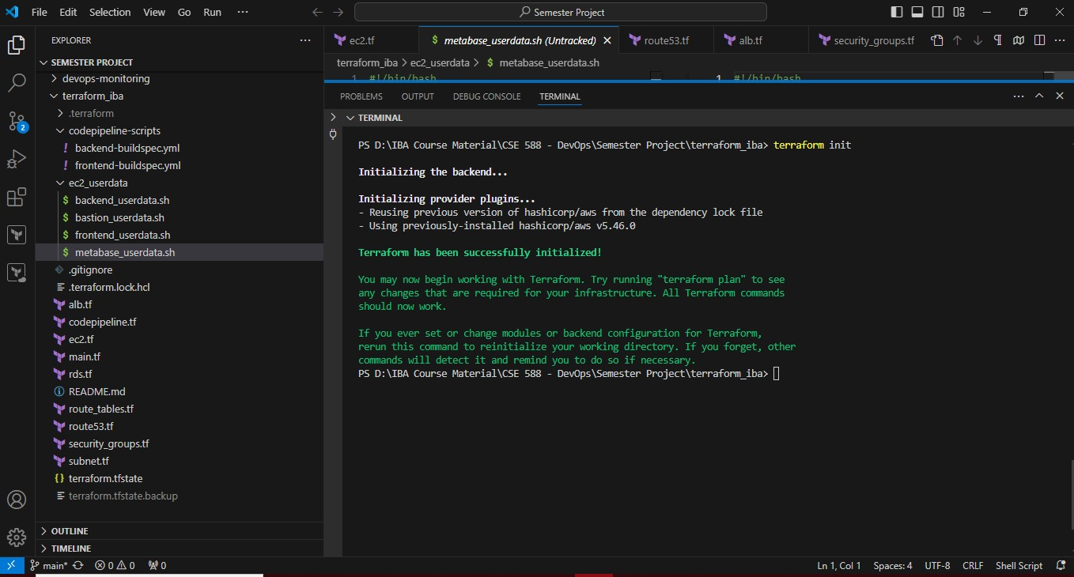
* Getting the plan before applying it  
  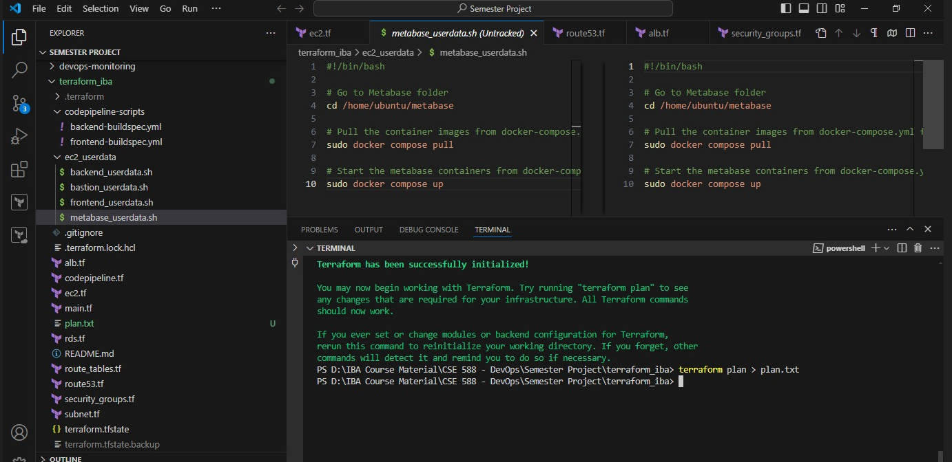
* Applying it to build the infrastructure:  
  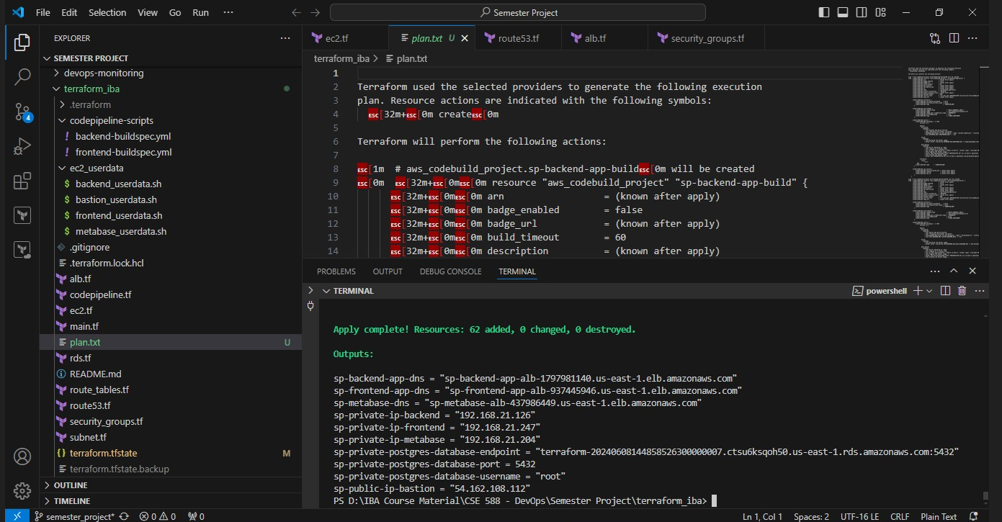

1. Create a VPC with the help of Terraform having following attributes;   
   - 3 Public and 3 Private Subnets.   
   - NAT GW for Private Subnets.   
   - IGW for Public Subnets.   
   - 1 Route Table for Private Subnets.   
   - 1 Route Table for Public Subnets.   
   - Launch 3 EC2 instances with any OS of your choosing and install Nginx, Docker, NodeJS 20 via ec2 user data.   
   - Launch 1 RDS in Create Private Subnet. ( MySQL or PSQL )   
   - Security Groups for each EC2 and RDS.

**ANSWER:**

* Configured a VPC with 3 public and 3 private subnets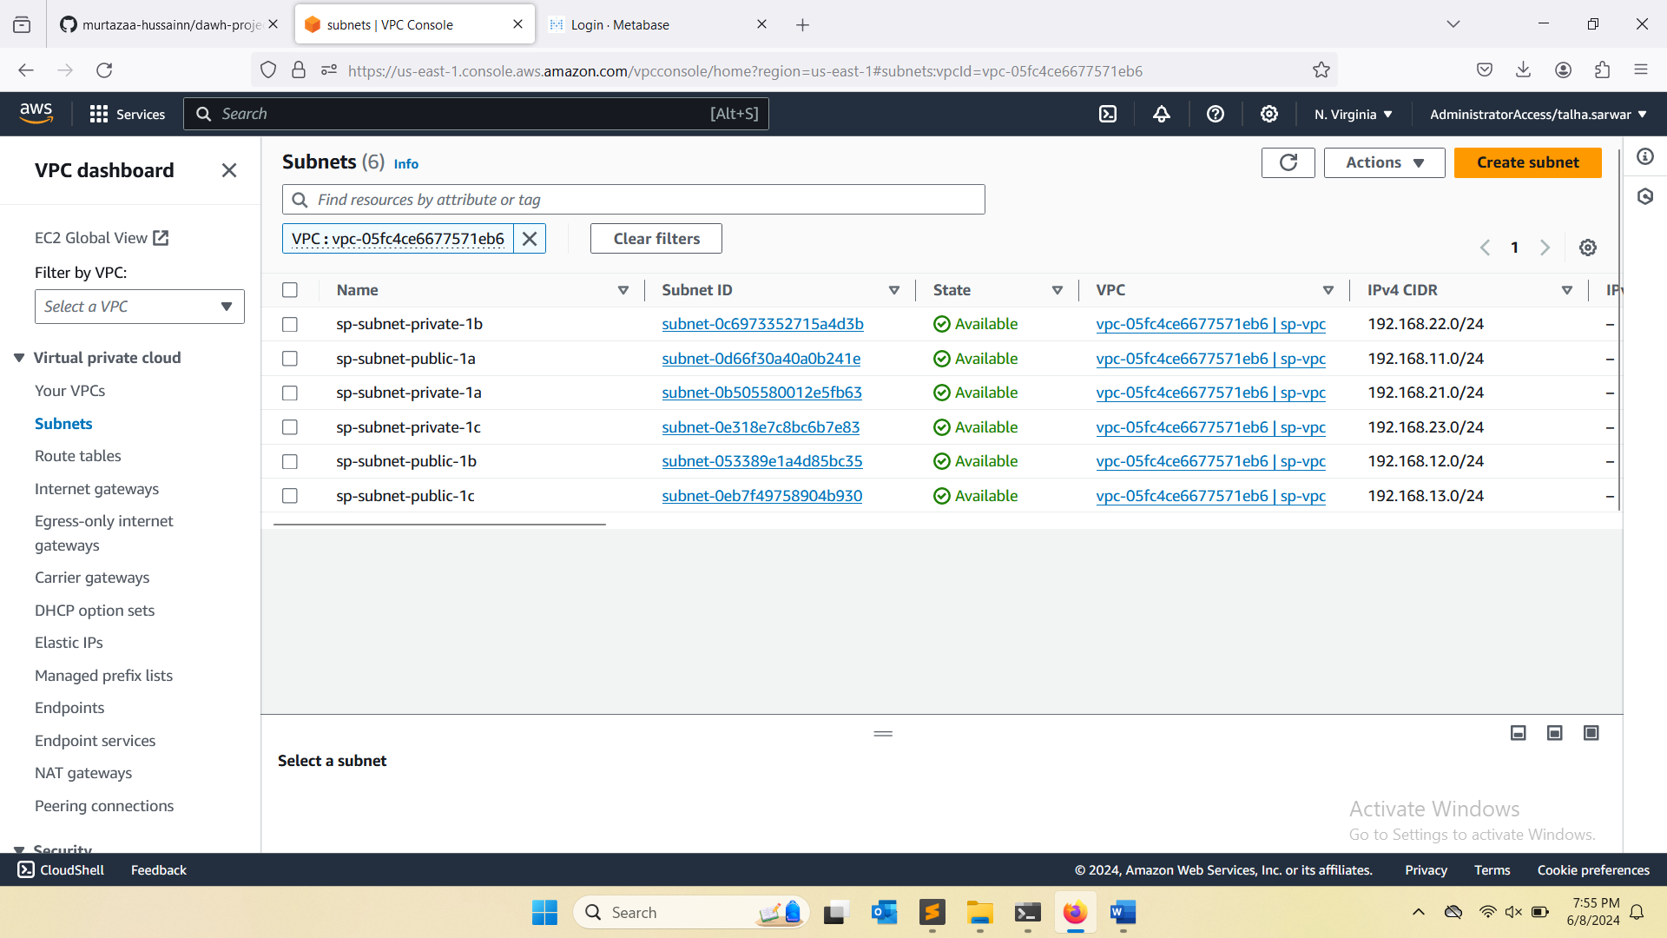
* NAT Gateway setup for private subnets to allow outbound internet access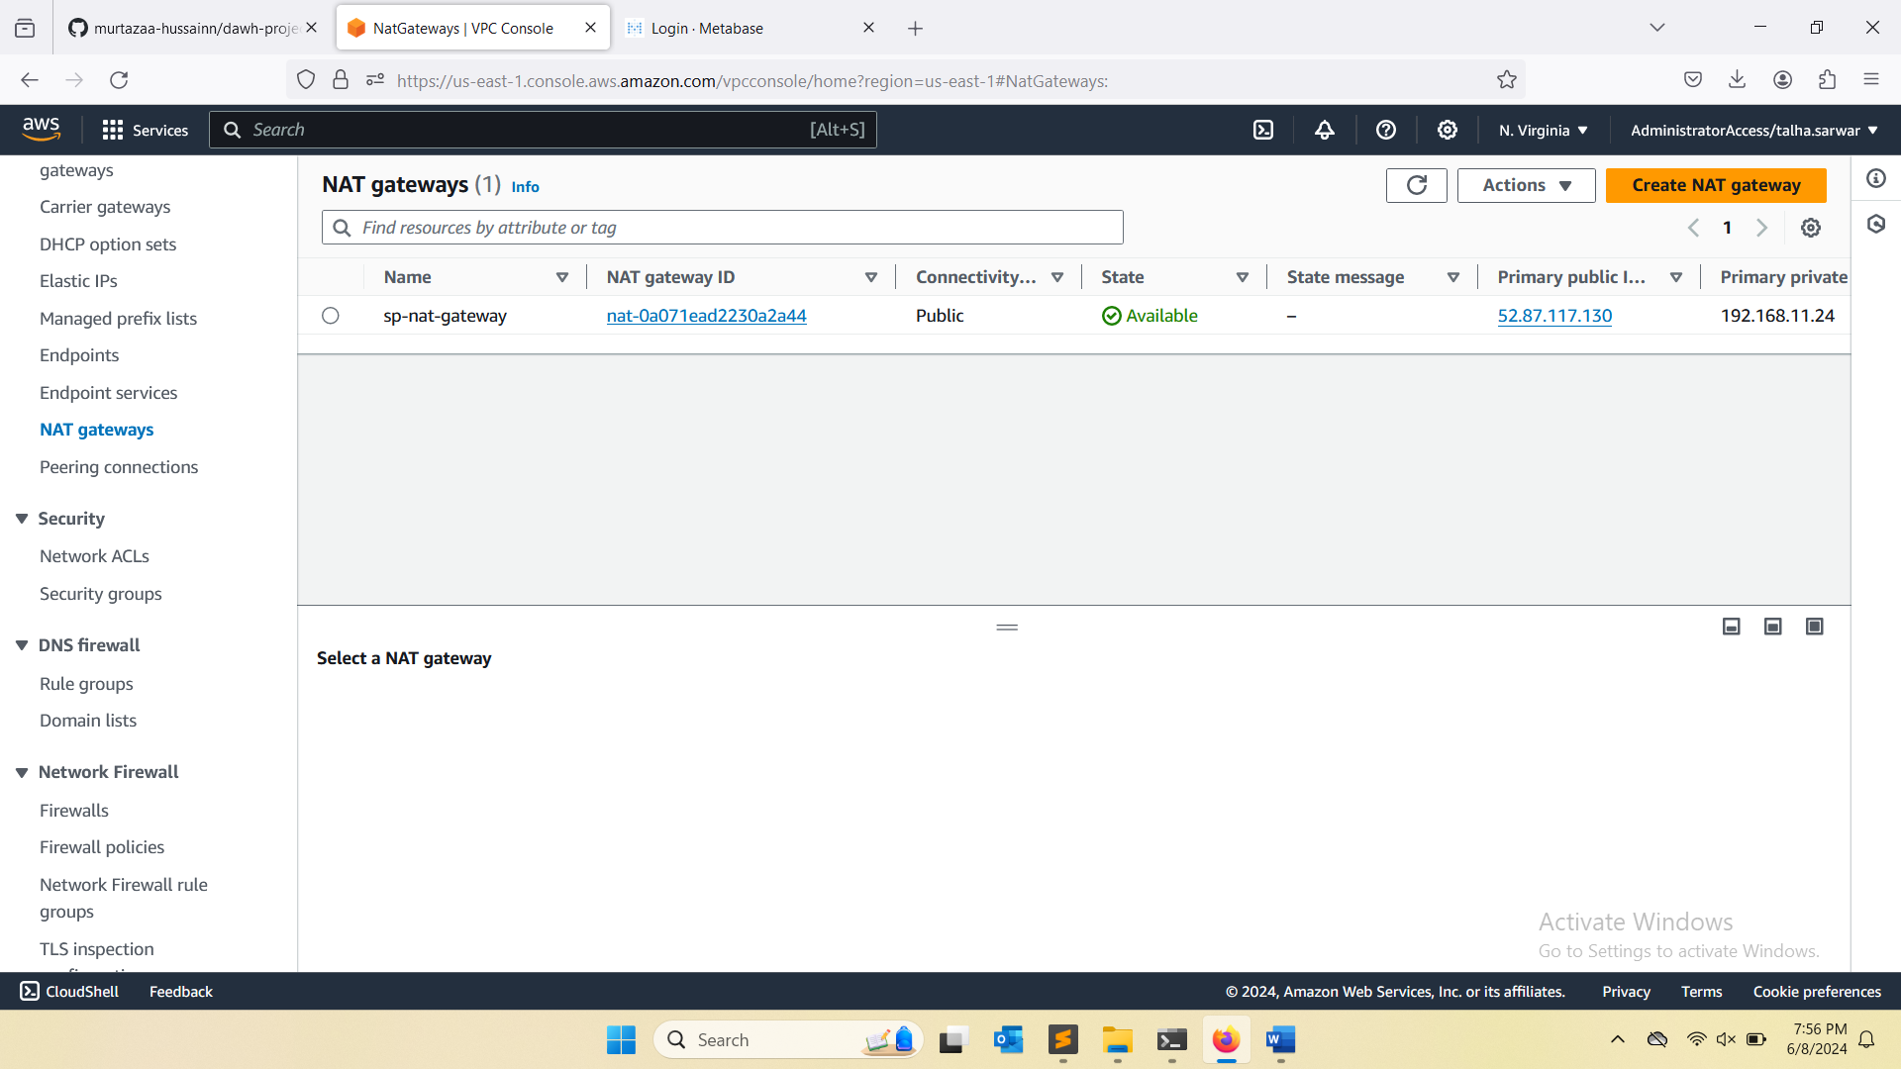
* Internet Gateway setup for public subnets to enable internet connectivity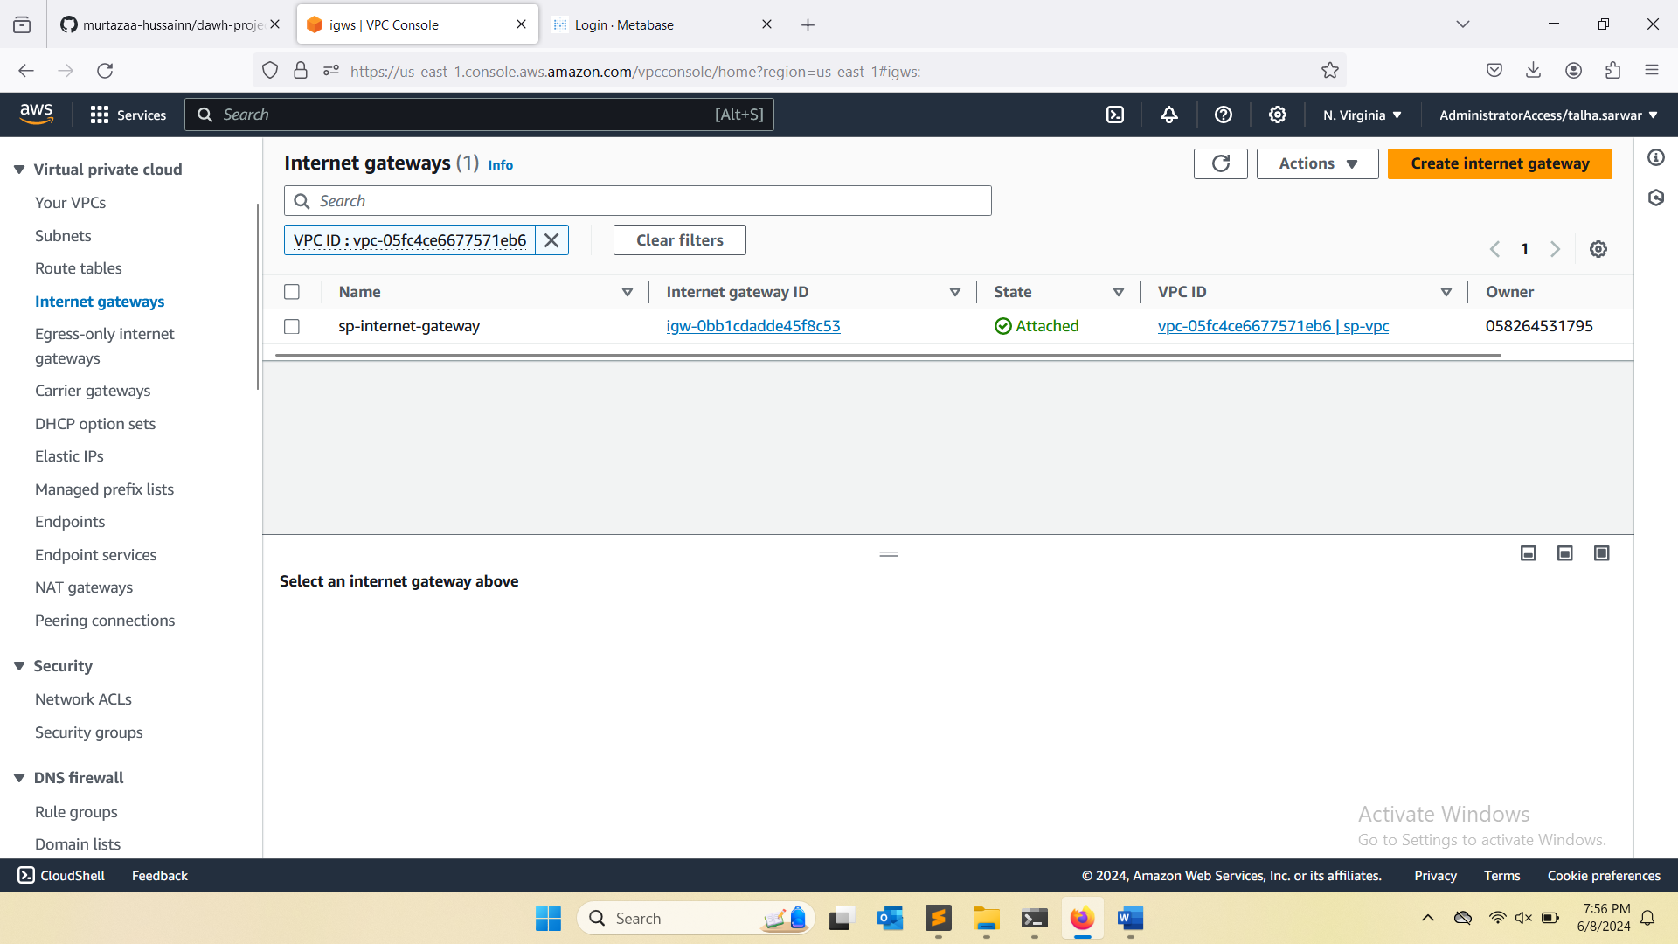
* Route table configured for public subnets with routes to the IGW.  
  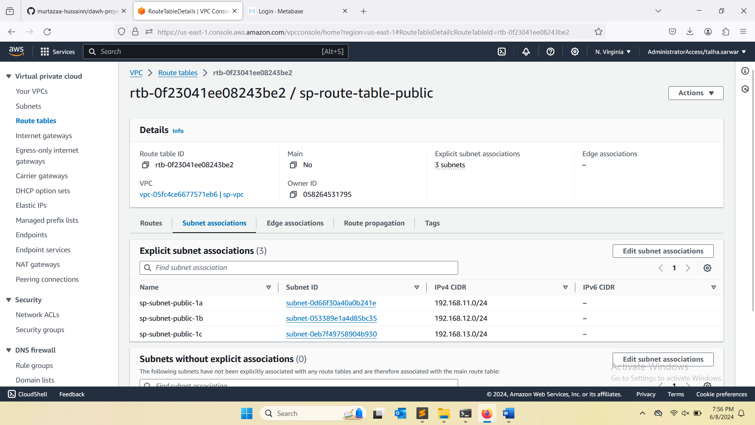
* Route table configured for private subnets with routes through the NAT Gateway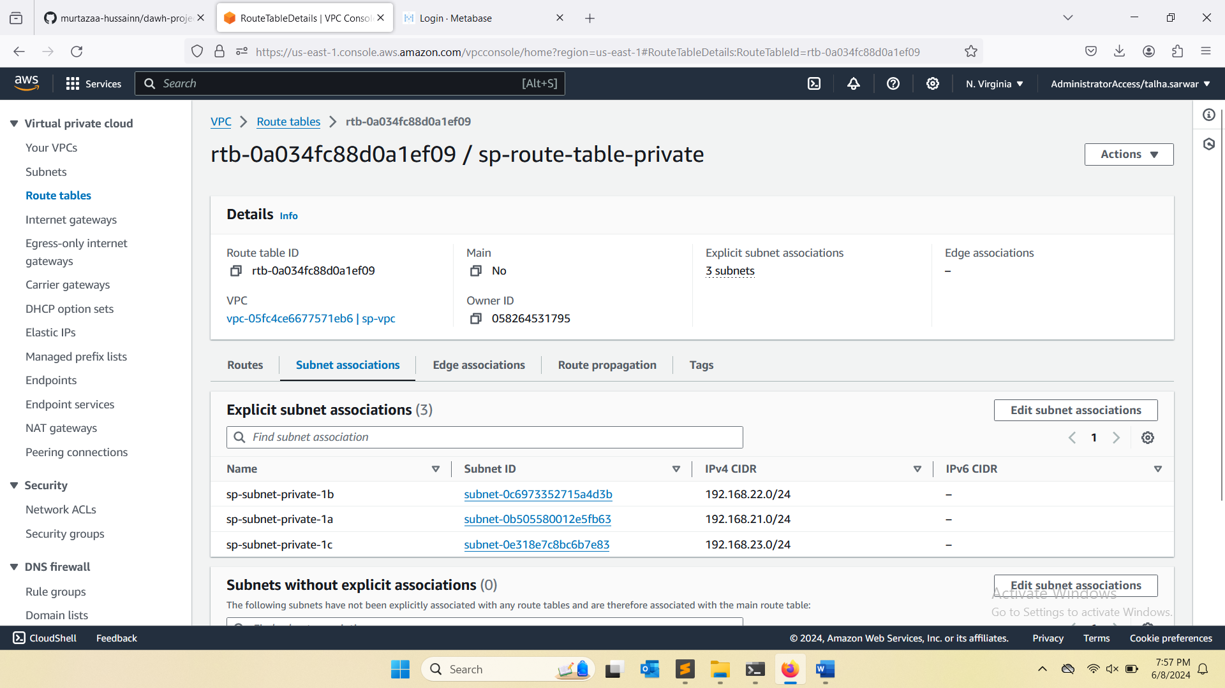
* Launched 3 EC2 instances and installed Nginx, Docker, and NodeJS 20 via user data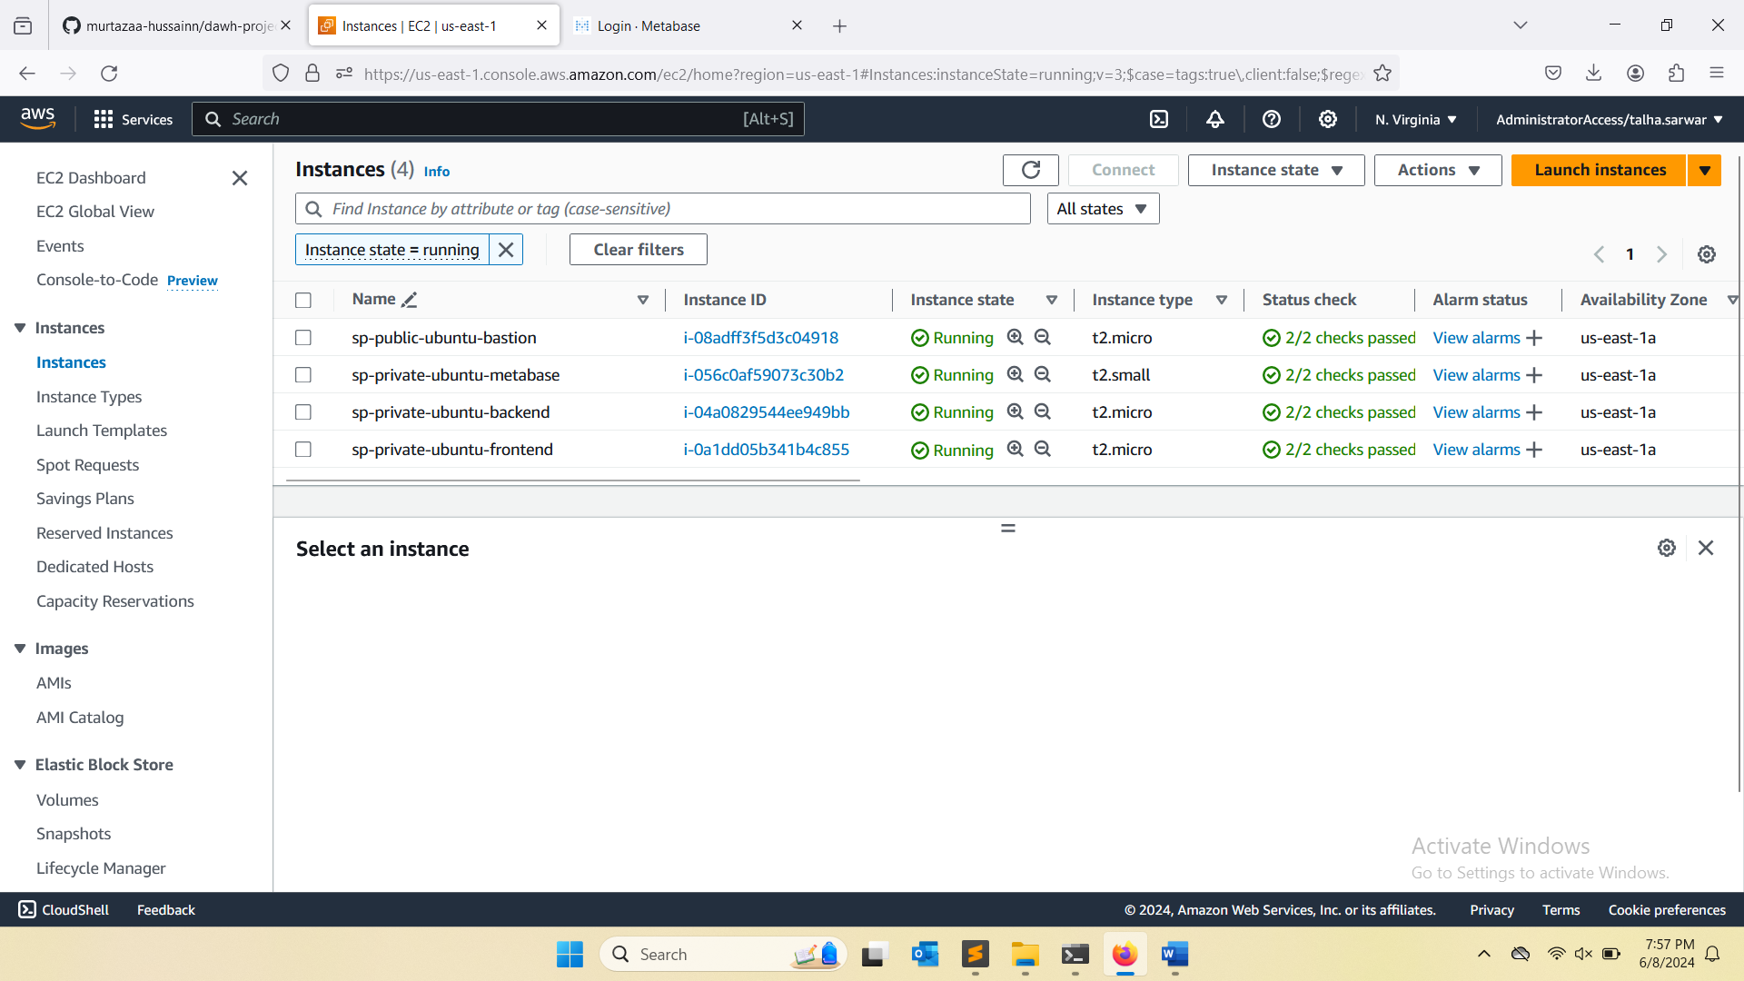
* RDS instance launched in a private subnet for database operations  
  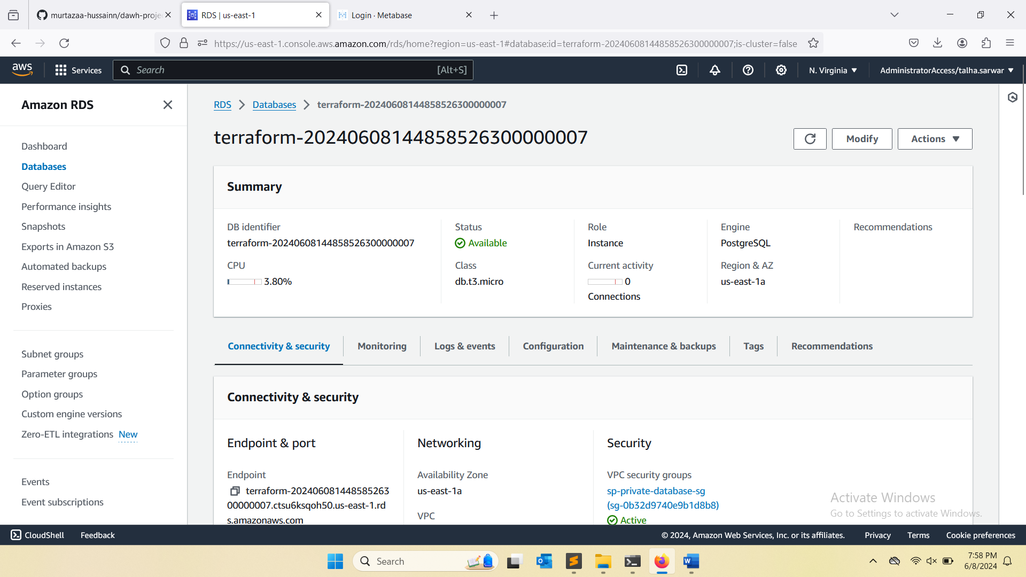
* Security groups configured for EC2 and RDS instances ensuring proper access controls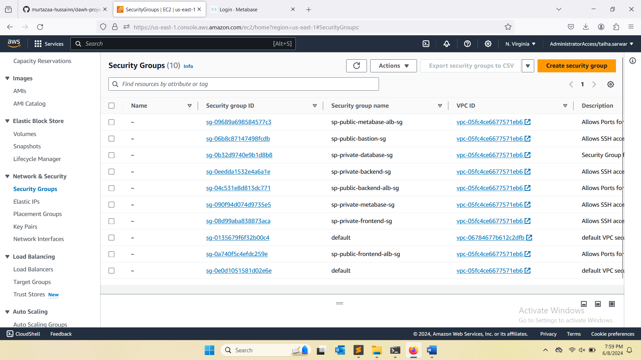

1. Create a Load Balancer to be attached on EC2 instances that are in Private Subnets for accessing the Frontend and Backend Application.   
   - Do it with the help of Terraform also create security group for load balancer with port 80 and 443 only.

**ANSWER:**

* Load Balancer setup to distribute traffic across EC2 instances in private subnets.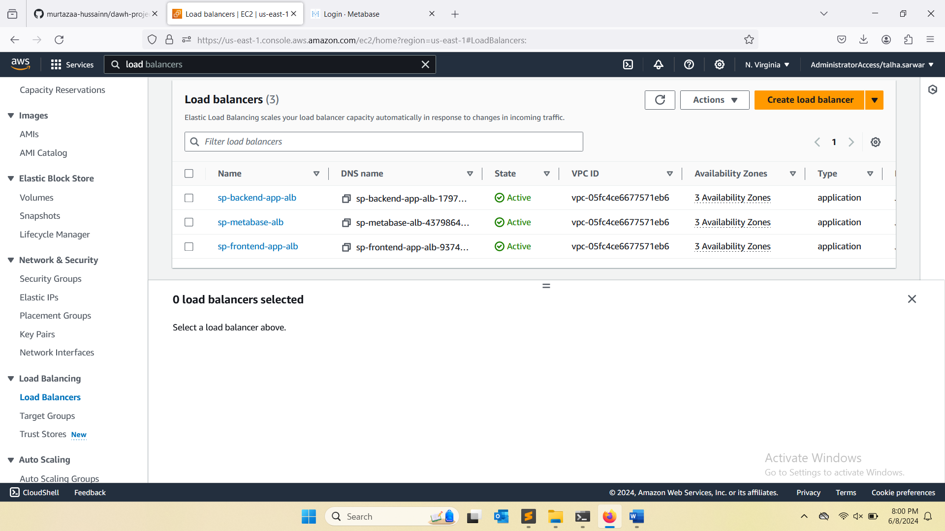

1. Deploy containerized frontend and backend applications on 2 different EC2 instances separately with any CICD tool of your choosing (AWS CodePipeline, Jenkins or Github actions and it should auto trigger the build when the code is pushed on git repo).   
      
   You can also create and use your own Frontend and Backend. Applications also need to be behind a Domain and SSL.

**ANSWER:**  
- Implemented a CI/CD pipeline using AWS CodePipeline for backend deployment  
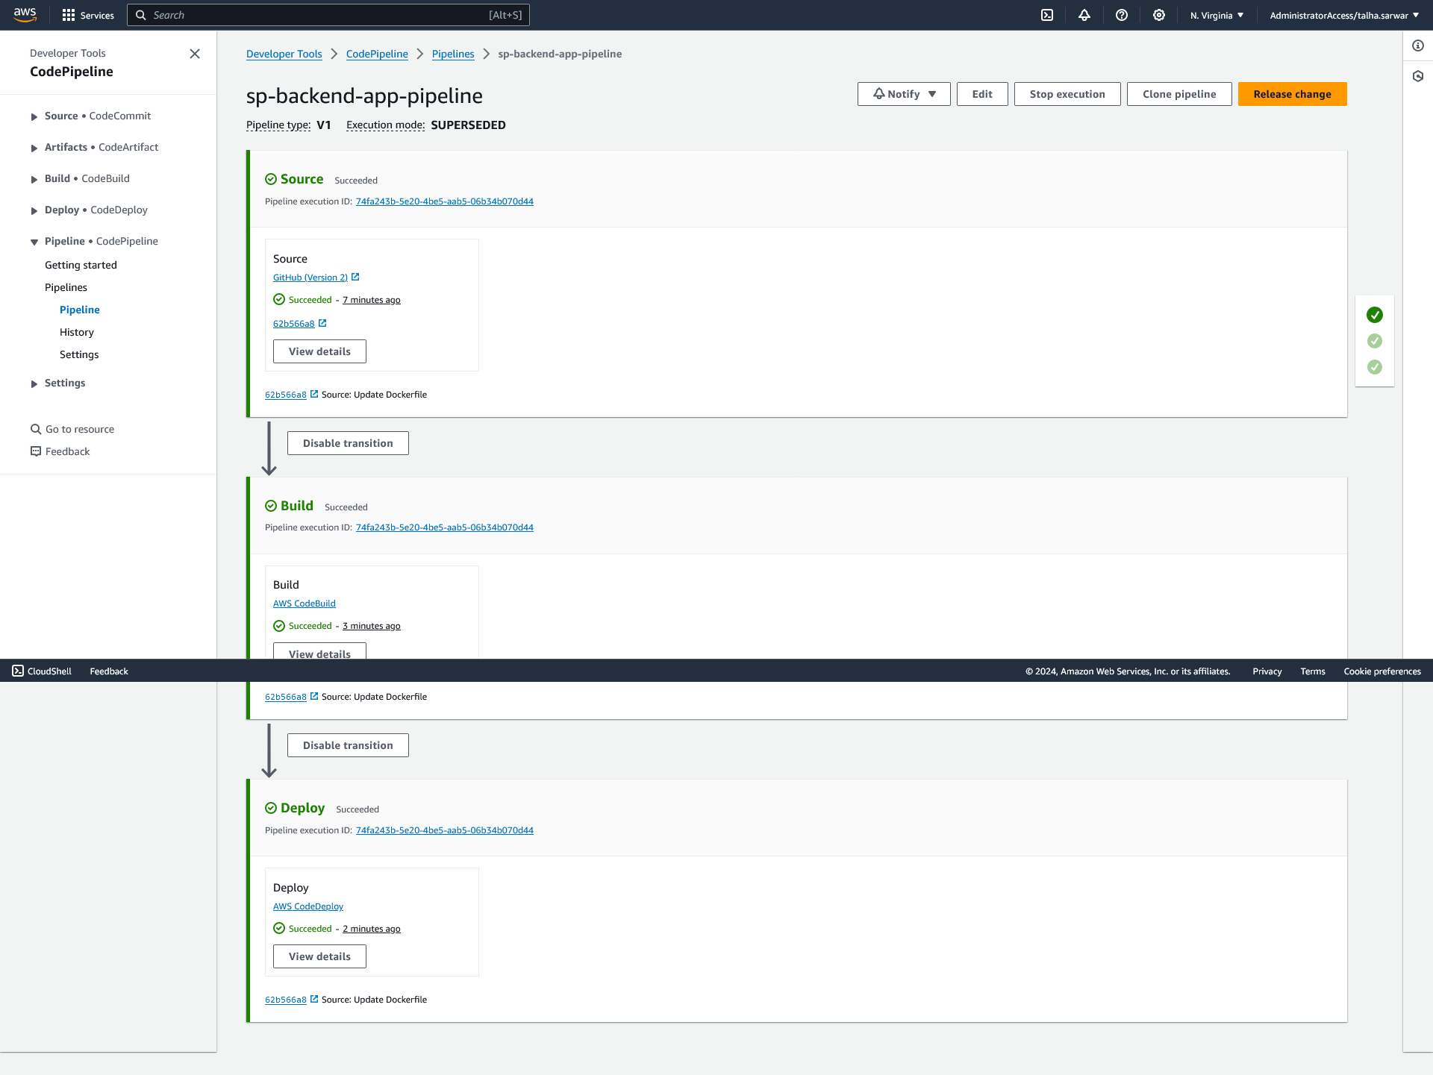  
  
- Implemented a CI/CD pipeline using AWS CodePipeline for frontend deployment  
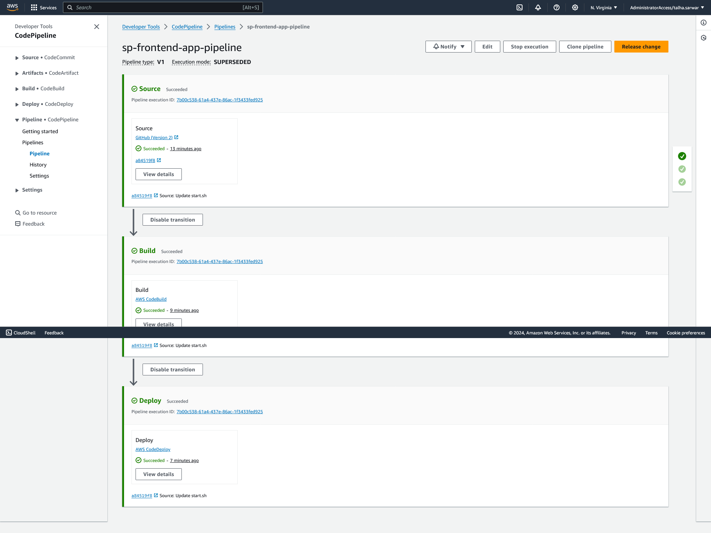

1. Populate the Database from the inputs that are being given to the Frontend which then passed to Backend and ultimately to the DB. You can also add dummy data into the database.

**ANSWER:**

* Database instance before entering any value from frontend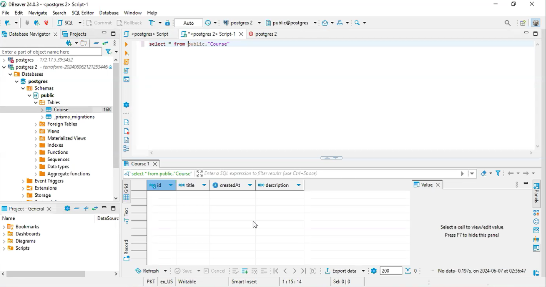
* This is our frontend and we are entering our first record  
  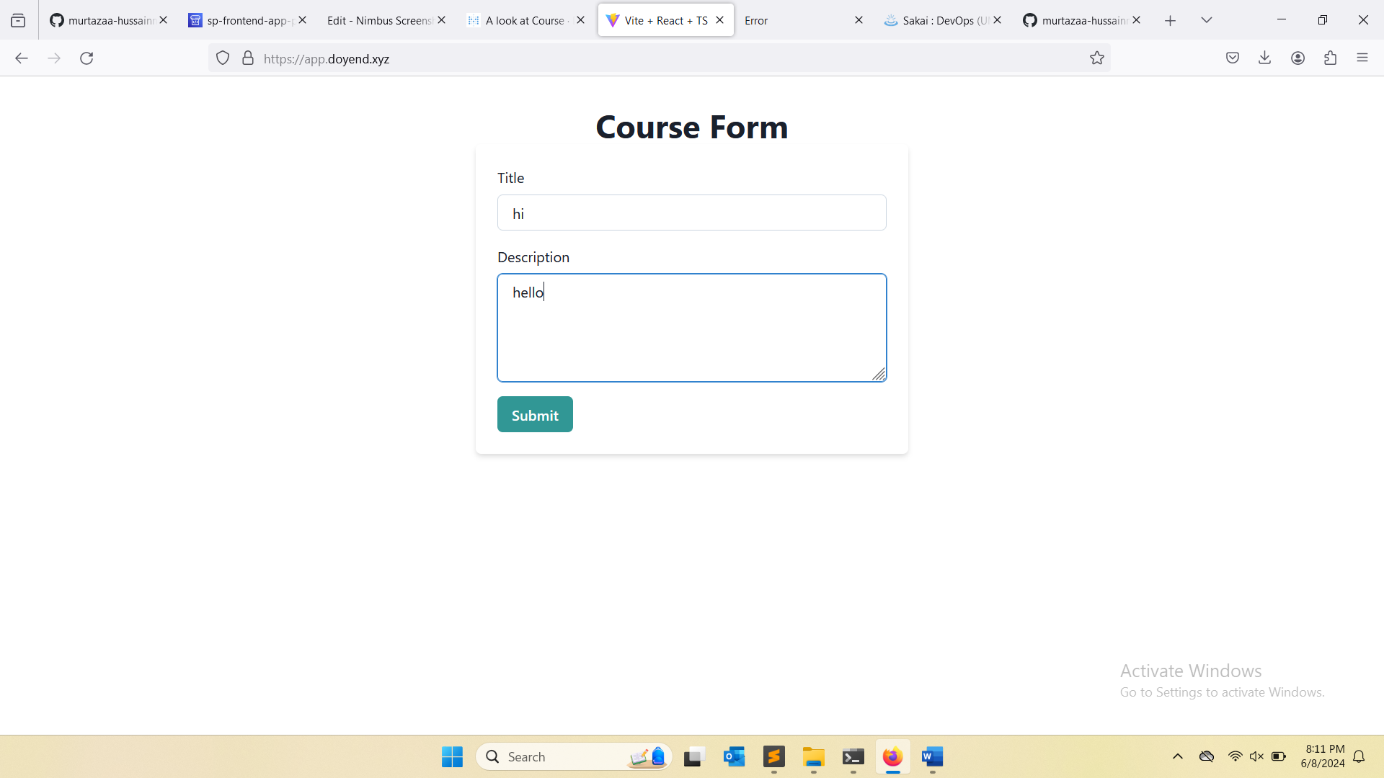
* Below response is to make sure it is connected from backend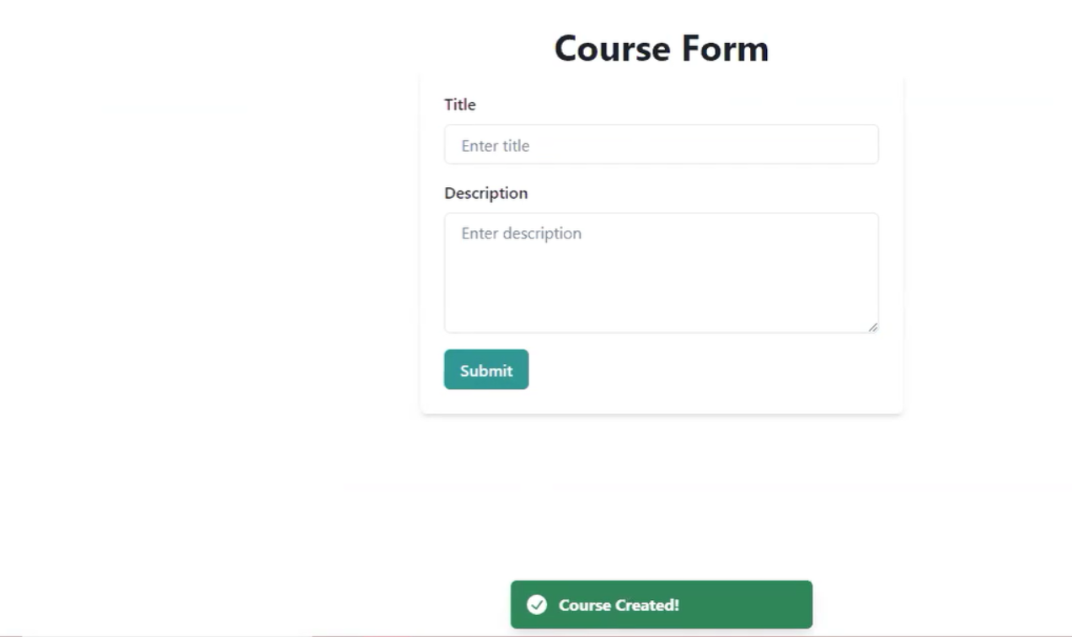
* Record has successfully inserted in the table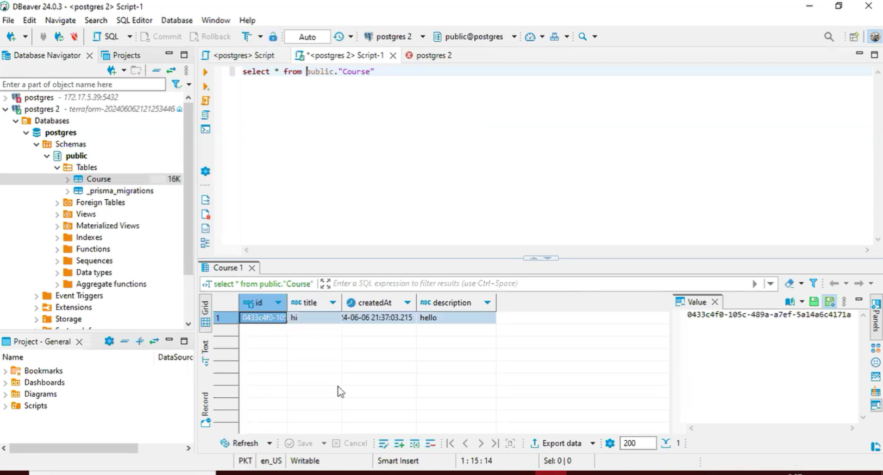

1. Deploy a BI Tool via Docker on a separate EC2 for example Redash or Metabase and connect it with your DB and create a sample dashboard. Also show the new data coming in to the Dashboard or BI Tools once you enter an entry to the DB from Frontend/Webapp.

**ANSWER:**

* Initial image of dashboard before inserting any records in the table  
  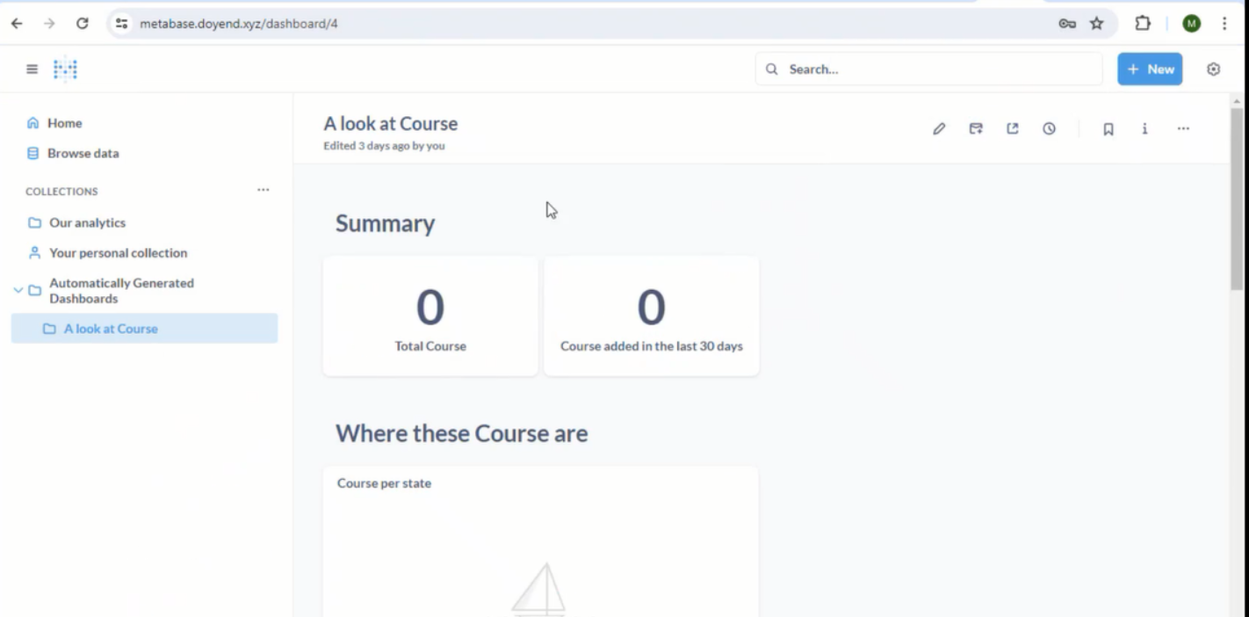
* Now entering 2 records into the database from frontend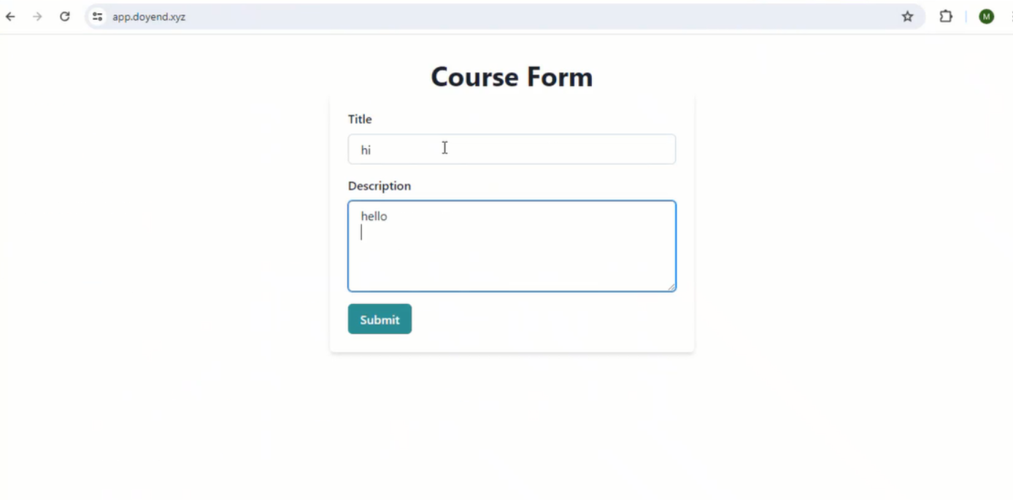

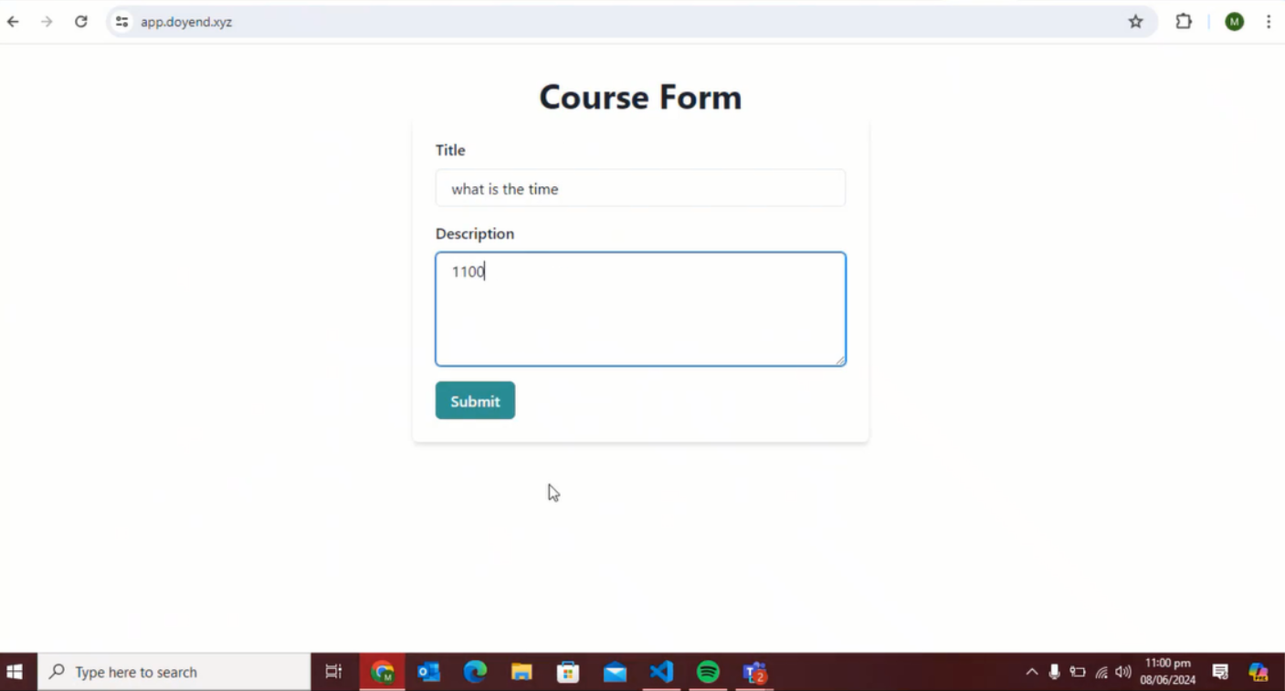

* New incoming data is displayed in the dashboard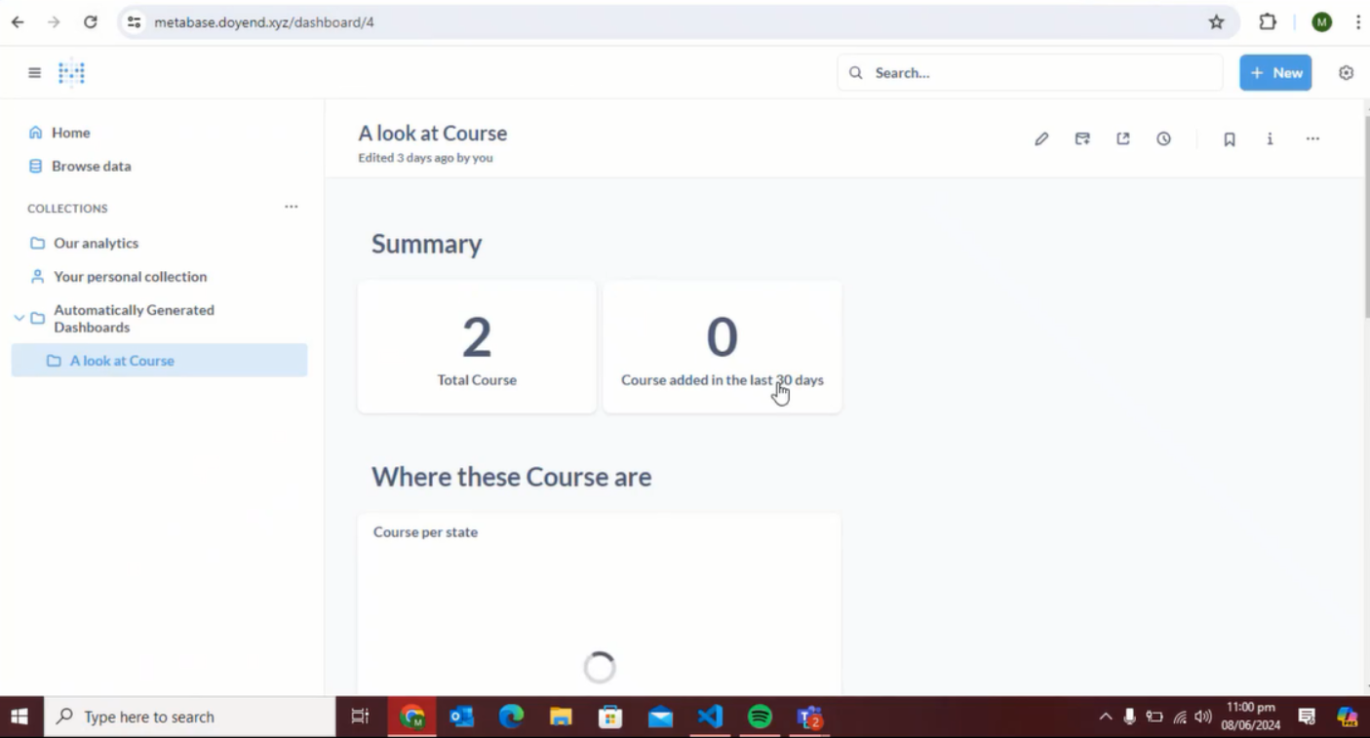

1. Try to apply Domain and SSL on every website i.e frontend, backend and redash/metabase.

**ANSWER:**

* SSL applied on backend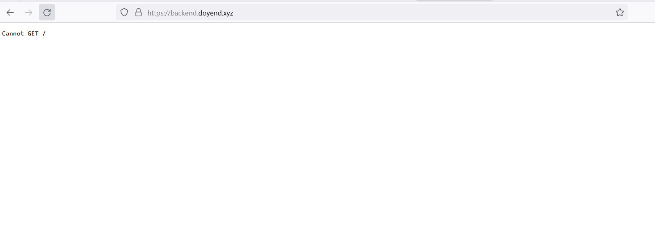
* SSL applied on metabase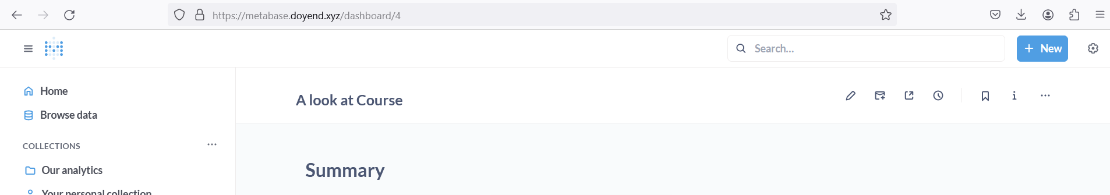
* SSL applied in frontend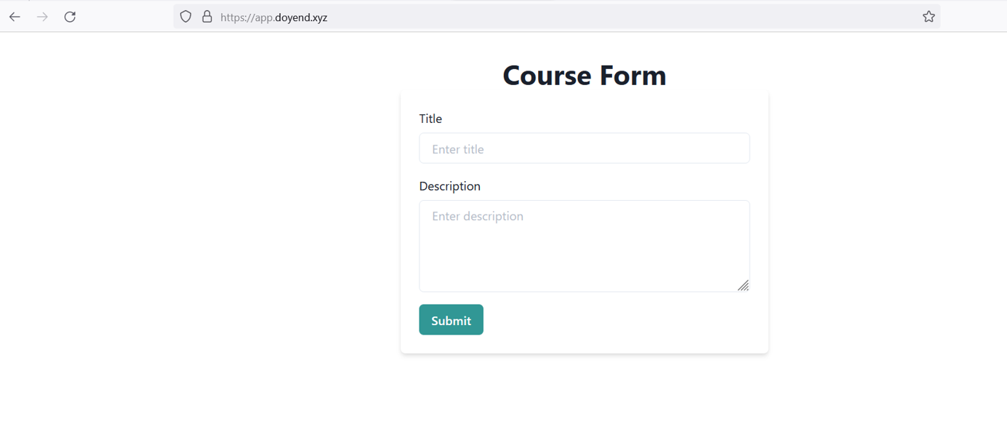

1. Create a Loom video demonstrating all the aforementioned tasks and add a Git Repo for Terraform Code in a PDF along with a brief report.

**ANSWER:** LOOM video added in git repo